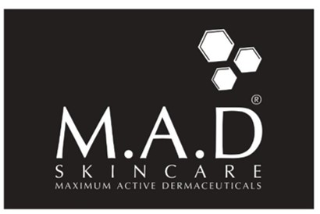

M.A.D “TWO STEP” PEDICURE PROTOCOL
STEP 1.) Use normal foot exfoliator tool to remove any heavy dead skin and calluses.
STEP 2.) ENZYMAXX – Use ample product to cover entire foot and lower calf if desired. With gloved hands massage Enzymaxx for 3 minutes into skin. Apply extra product if needed. Let feet sit an additional 10 minutes. Remove with water and pat dry.
STEP 3.) Apply PEDI PRO 20 to feet and lower calf if desired. Massage until product is fully absorbed. Let air dry. Client service is complete! Don’t forget to send them home with a RETAIL PEDI PRO product to keep their beautiful results going!

